

**22/SP-COP-2800 Java Programming**

**Assignment 1.1**

Document Version: 0.1

Version Date: August 20, 2022

Created By: Jonathan Gan

# Document Version Control

|  |  |  |  |
| --- | --- | --- | --- |
| Version | Date | Author | Rationale |
| 0.1 | 2022 AUG 20 | Jonathan Gan | First Draft |

# Document Purpose

The prompt asked us to print 3 lines of string “Welcome to Java” “Welcome to Computer Science” and “Programming is fun”

# Technical Specifications

## Purpose of Technical Implementation

Using *System.out.println(String)* we were able to print out the specified lines of string

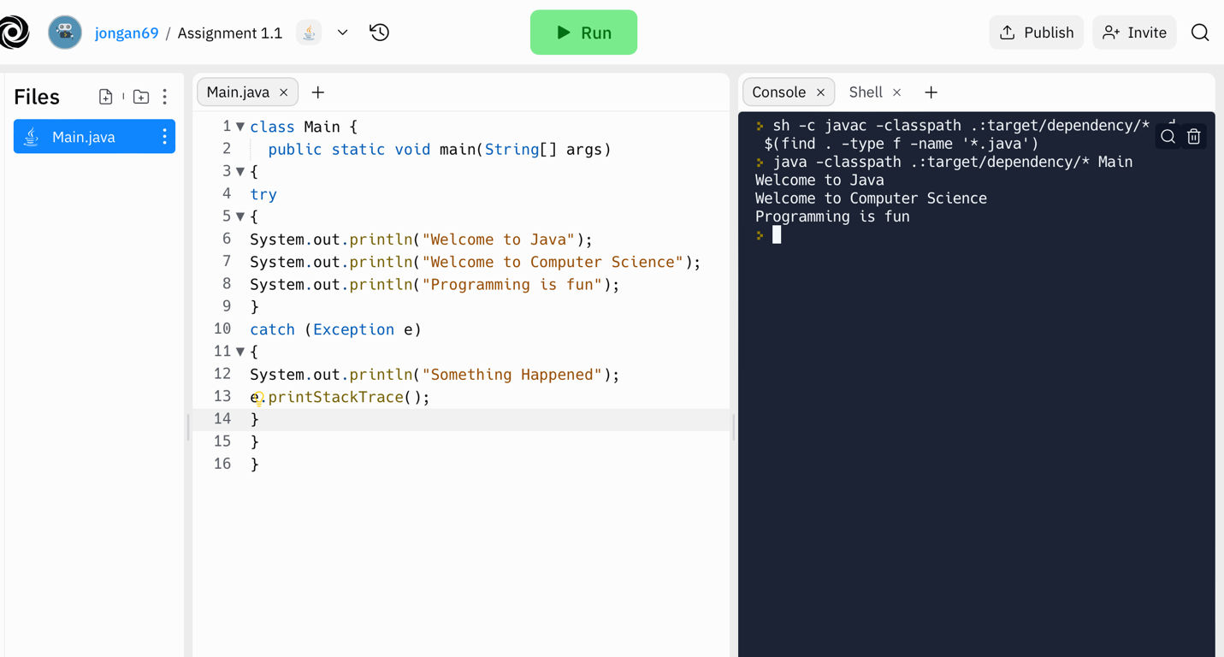

REPL.IT URL:

<https://replit.com/@jongan69/Assignment-11?v=1>

## Technical Implementation Components

## Technical Implementation Pseudocode

## PageBuilderService Implementation

## Implementing a Dynamic page